Sequencing in tissues – Explore biological processes at the single base resolution with novel (micro-)fluidics

Thesis Proposal
In this project you will participate in an interdisciplinary research team with the goal of developing state-of-the-art sequencing technologies inside biological tissues. The specific goal of the thesis project is to develop and implement microfluidics coupled to microscopy for optical read out of gene sequences and protein localization.

Next generation sequencing (NGS) has revolutionised medicine and life science research. We can now routinely extract genetic information from single cells. Single-cell sequencing has become a very popular and successful way of addressing many research questions in the life sciences. A major limitation however, is that these methods mostly omit that tissues have a spatial (3D) context consisting of cells interacting with their surroundings.

Depending on candidate, different focus areas can be chosen, e.g a more software and method developmental approach with programming of the fluidics system or a more hardware development oriented focus including some prototyping and electronics.

Applications range from exploring the composition of brain tissues, monitoring cell responses, medical diagnostics, and to provide a molecular understanding of developmental processes.

This work will be performed in collaboration with research groups at LTH and at the medical faculty at the university.

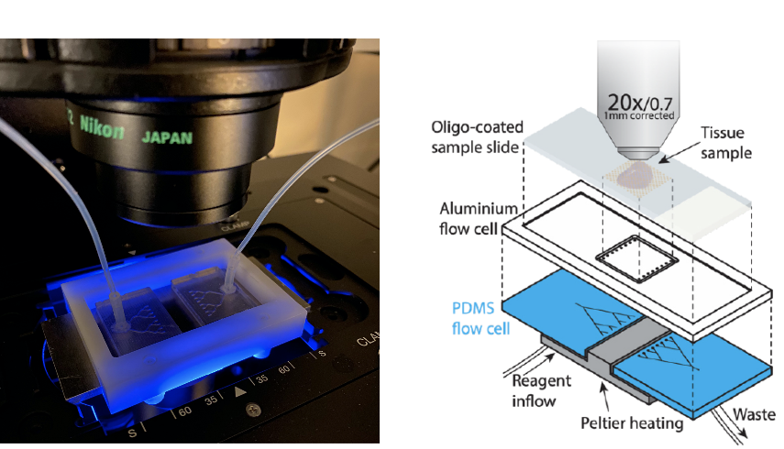
Figure: The first microfluidics prototype for sequencing of genetic sequences inside brain tissue. This allows for simultaneous temperature control, liquid exchange and imaging at a sub-cellular resolution.

Contact: Dr. Nils Norlin, Dept. Experimental Medical Science and Lund bioimaging centre.
Email: nils.norlin@med.lu.se
Prof. Tomas Björklund, Dept. Experimental Medical Science
Email: tomas.bjorklund@med.lu.se

