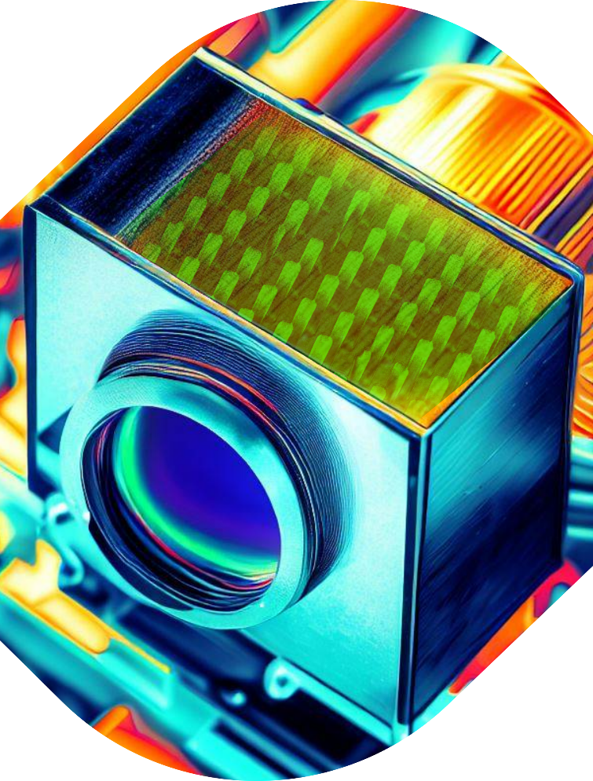
Method tags: Characterization, Experiment, Modelling
Scientific tags: Photonics, Devices Development, X-rays

Supervisor: Jens Uhlig, jens.uhlig@kemfys.lu.se

Website: https://portal.research.lu.se/en/persons/jens-uhlig
We are excited to offer a master thesis opportunity in Physics, Electrical Engineering, or Chemistry to develop a new type of detector for X-ray fluorescence using semiconductor nanowires.
We are aiming to build a new generation of x-ray detectors based on a new design of nano-wires. Originally developed for infrared spectroscopy, our innovative material system utilizes the complex electronic surfaces of nanowires to produce a very high optical gain, i.e. many charge carriers for a single absorbed x-ray photon. This high gain increases both the sensitivity and spectral resolution that can be achieved with a detector. This promising development has wide-reaching applications in various industries, such as analyzing color pigments in images, detecting contaminations in food, and metal analysis.
As a master student, you will build a small light-tight chamber with a pre-amplifier and potentially an AD converter based on Arduino, and then test the nanowire detectors with a tabletop X-ray source or the cutting-edge synchrotron radiation facility, MaxIV. With our pre-tests showing that this type of detector works in principle, the main objective will be to perform more careful tests and build a prototype to evaluate its real performance.
The ideal candidate should have some experience with microelectronics and be excited about working independently on this project for 3-6 months. This is an excellent opportunity to make a significant contribution to scientific advancement and potentially develop a product with a wide reach. Join us in this exciting journey to push the boundaries of modern detection technology!

