Nanoplastics from packaging of fruits and vegetables – Tommy Cedervall
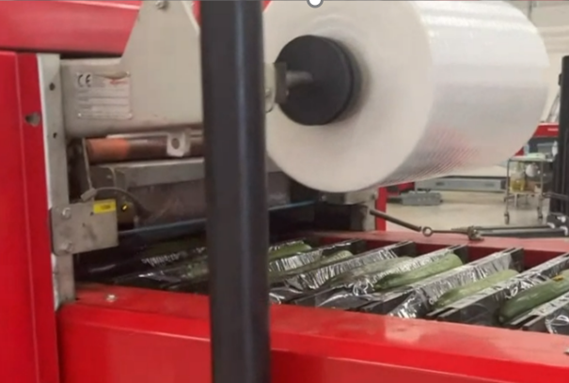

Method tags: Plastic breakdown, isolation, and characterization

Scientific tags: Nanoplastics in food, food packaging, nanotoxicity

Supervisor: Tommy Cedervall tommy.cedervall@biochemistry.lu.se, Vahid Sohrabpour vahid@saveggy.com

Web site: https://portal.research.lu.se/en/persons/tommy-cedervall, https://saveggy.com

We will break down packaging plastics to nano and micro-sized plastics and use it as a standard to isolate and characterise nano and microplastics in cucumbers wrapped in plastics. We will compare the results with not wrapped cucumbers. The study is important for development of new packaging methods and potentially for the human health.

